**10. Sum of Evens**

# Program Name: sumofevens.ypr

Find the sum of all the even numbers in a list of 10 numbers.

**Example Input File**

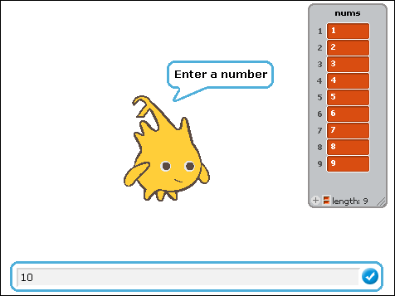

**Example Output to Screen**

